

**Western Australian Certificate of Education**

**ATAR course examination, 2020**

**Question/Answer Booklet**

11 PHYSICS

Name

**Test 3 - Heating and**

**Cooling**

|  |  |  |  |  |  |  |  |  |  |  |
| --- | --- | --- | --- | --- | --- | --- | --- | --- | --- | --- |
| Student Number: In figures |  |  |  |  |  |  |  |  |  |  |

**Mark: $\frac{}{\text{35}}$** In words

#### Time allowed for this paper

Reading time before commencing work: five minutes

Working time for paper: fifty minutes

**Materials required/recommended for this paper**

To be provided by the supervisor

This Question/Answer Booklet

Formulae and Data Booklet

***To be provided by the candidate***

Standard items: pens, (blue/black preferred), pencils (including coloured), sharpener, correction fluid/tape, eraser, ruler, highlighters

Special items: non-programmable calculators satisfying the conditions set by the School Curriculum and Standards Authority for this course

**Important note to candidates**

No other items may be taken into the examination room. It is your responsibility to ensure that you do not have any unauthorised notes or other items of a non-personal nature in the examination room. If you have any unauthorised material with you, hand it to the supervisor before reading any further.

**Structure of this paper**

|  |  |  |  |  |  |
| --- | --- | --- | --- | --- | --- |
| Section | Number of questions available | Number of questions to be answered | Suggested working time  (minutes) | Marks available | Percentage of exam |
| Section One:  Short Answers |  |  |  |  |  |
| Section Two:  Problem-solving | 7 | 7 | 50 | 35 | 100 |
| Section Three:  Comprehension |  |  |  |  |  |
|  |  |  |  | **Total** | 100 |

**Instructions to candidates**

1. The rules for the conduct of examinations at Holy Cross College are detailed in the College Examination Policy*.* Sitting this examination implies that you agree to abide by these rules.

2. Write your answers in this Question/Answer Booklet.

3. Working or reasoning should be clearly shown when calculating or estimating answers.

4. You must be careful to confine your responses to the specific questions asked and to follow any instructions that are specific to a particular question.

5. Spare pages are included at the end of this booklet. They can be used for planning your

responses and/or as additional space if required to continue an answer.

• Planning: If you use the spare pages for planning, indicate this clearly at the top of the page.

• Continuing an answer: If you need to use the space to continue an answer, indicate in the original answer space where the answer is continued, i.e. give the page number.

Fill in the number of the question(s) that you are continuing to answer at the top of the page.

6. Answers to questions involving calculations should be ***evaluated and given in decimal***

***form*.** It is suggested that you quote all answers to ***three significant figures***, with the

exception of questions for which estimates are required. Despite an incorrect final result, credit may be obtained for method and working, providing these are ***clearly and legibly set out***.

7. Questions containing the instruction "estimate" may give insufficient numerical data for their solution. Students should provide appropriate figures to enable an approximate solution to be obtained. Give final answers to a maximum of two significant figures and include appropriate units where applicable.

8. Note that when an answer is a vector quantity, it must be given with magnitude and direction.

9. In all calculations, units must be consistent throughout your working.

**DATA**

Use the data sheet plus the following table.

|  |  |
| --- | --- |
| **Table of Specific Heats (Jkg-1K-1)** | |
| water | 4.18 x 103 |
| pewter | 1.43 x 102 |
| steam | 2.00 x 103 |
| glass | 8.40 x 102 |
| ice | 2.10 x 103 |
| aluminium | 8.80 x 102 |
| ethylene glycol | 2.40 x 103 |
| air | 1.00 x 103 |
| copper | 3.90 x 102 |
| stainless steel | 4.45 x 102 |
| lead | 1.30 x 102 |
| human body (average) | 3.50 x 103 |

1. Explain the difference between the terms ***heat*** and ***temperature***. (2 marks)

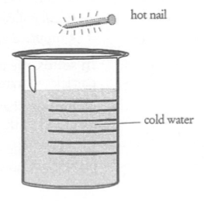

2. A nail was heated in a blue Bunsen burner flame for one minute and is about to be dropped into a beaker holding 0.60 L of water at room temperature.

(a) Which of the two (nail or water) would be expected to initially have:

(i) the highest internal energy?

(ii) the highest average kinetic energy? (2 marks)

(b) The nail is dropped into the water and allowed to cool. What happens to the average kinetic energy of the atoms in the:

(i) nail?

(ii) water? (2 marks)

3. (a) What is 143 K in °C? (1 mark)

(b) Comment on the statement:

"At 40 °C, tomorrow is going to be twice as hot as the 20 °C today."

Is this true? Give an explanation for your answer. (3 marks)

4. Calculate the specific heat of a metal sample if 5.25 x 107 J of heat is required to raise the temperature of 245 kg of it from 25 °C to 455 °C. (3 marks)

5. (a) How much heat energy is required to convert 47.6 g of ice at - 8.0 °C to water at

79.0 °C? (4 marks)

(b) Draw a heating curve (temperature versus time) for the ice changing from - 8.0 °C to steam at 110 °C, indicating clearly where the phase changes occur. (3 marks)

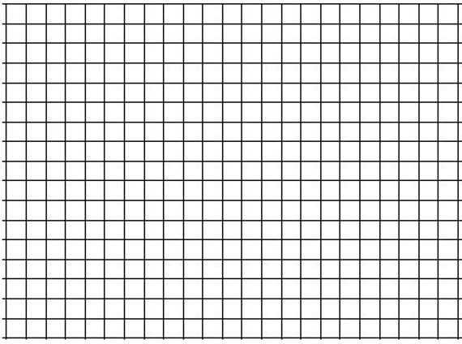

(c) Why is there a plateau in the heating curve for water turning into steam? Using the Kinetic Theory, explain what is occurring at the molecular level. (3 marks)

6. A 145 g copper calorimeter inside wood insulation contains 86.3 g of water at 73.0 °C. What mass of ice at - 5.0 °C is required to lower the temperature to 21.0 °C? (Assume no heat is lost to the surroundings.) (4 marks)

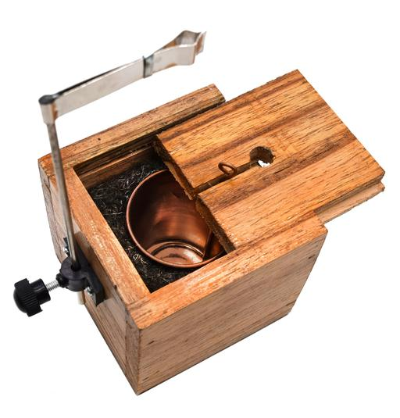

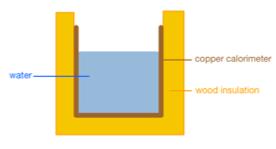

7. A microwave rated at 1.10 kW is used to heat a 215 g porcelain cup holding 275 mL of water from 18.0 °C to 90.0 °C. Given cporcelain = 1085 Jkg-1K-1 and the microwave is 68.0% efficient, calculate:

(a) how long it takes to heat the water. (5 marks)

(b) the cost of heating the water, given 1.00 unit of electrical energy costs 28.8 cents.

(3 marks)